REPUBLIC OF CAMEROON
Peace - work - Fatherland
MINISTRY OF HIGHER EDUCATION

REGIONAL DELEGATION OF CENTER

PKFokam Institute of Excellence

Dignity - Faith – Responsibility
P.O.BOX 11646 Yaoundé – Cameroon
RÉPUBLIQUE DU CAMEROUN
Paix - travail – Patrie
MINISTÈRE DE L’ENSEIGNEMENT SUPÉRIEUR

DÉLÉGATION REGIONALE DU CENTRE

PKFokam Institute of Excellence

Dignité - Foi – Responsabilité
P.O. Box 11646 Yaoundé – Cameroun

Project Progress Report
Restaurant Management Web Application

Framework | Django (Python 3.x)
Database | MySQL Restaurant DB
Architecture | MVT (Model-View-Template)
Modules | 7 functional modules
Team Size | 4 students

Group Members | Participation
Pettang Feumba Roddy Alann | 20%
Tiofack Kaze Franck | 20%
Matchim Dzuyim Verenne Celia | 20%
Mekolle Tuatsop Dalhia Aure | 20%
Messi Zang Paul Jacques | 20%

LECTURER: Mr. mbieteu amos mb.
DATE: Friday, 7th march 2026
1. Introduction
As part of the Python Programming course delivered at the PKFIE Institute of Excellence, our group of four (4) students was tasked with designing and developing a comprehensive restaurant management web application. This application is built on the Django (Python) framework and uses a pre-designed MySQL database composed of 23 tables covering all the operational needs of a modern restaurant.
In order to efficiently organize our work and meet the project requirements, we divided the development of the application into three (3) distinct phases as follows:
Phase | Title | Description
Phase 1 | Setup & Configuration | Setting up the development environment, installing all required tools, creating the Django project, configuring MySQL and importing the existing database.
Phase 2 | Models & Application Foundation | Writing Django models corresponding to the 23 SQL tables, setting up the authentication system and user role management.
Phase 3 | Interfaces, Business Logic & Deployment | Building views, HTML templates, the dashboard, financial reports, implementing security measures and preparing all final deliverables.
This report documents the progress made during Phase 1, which forms the technical foundation of the entire application. Each step is presented with the commands used and a screenshot to support the work done.

2. Phase 1: Project Setup & Configuration
The goal of Phase 1 is to prepare the entire Django project structure before writing any application code. This phase covers seven (7) essential steps that were carried out in the order listed below.
Step 1: Installing the Required Tools
The first action was to install all the Python libraries needed for Django to function and to connect to MySQL. These installations were carried out using the pip tool in the Windows Command Prompt.

The following packages were installed:
- Django; the main Django web framework
- MySQL client; the connector that allows Django to communicate with MySQL
- pillow ; image handling Library
- python-decouple; stores sensitive credentials (passwords) in a separate .env file away from GitHub
Step 2: Creating the Django Project
After installing the required tools, we created the base Django project structure. This was done from the terminal inside our group's working folder.

django-admin startproject restaurant_project
cd restaurant_project

These commands automatically generate the following file structure:

restaurant_project/
├── manage.py ← Django entry point
└── restaurant_project/
├── settings.py ← main configuration file
├── urls.py ← main URL router
└── wsgi.py
Step 3: Creating One Django App Per Module
In line with the functional requirements of the project, each restaurant management module was translated into an independent Django application. This modular organization respects the MVT (Model-View-Template) architecture required by the project specifications.
The following eight (8) applications were created using the commands below and each command creates a folder containing the following base files (example with the orders app):
Application | Module Covered | SQL Tables Used
users | User Management | CustomUser (new table)
products | Product & Recipe Mgmt | Produit, Ingredient, Composition_Produit
orders | Order Management | Commande, Ligne_Commande, Client, Table, Reservation
inventory | Inventory Management | Stock, Variation_Stock, Approvisionnement, Fournisseur
hr | HR Management | Employe, Poste, Affectation, Supervision
delivery | Delivery Management | Livraison, Deplacement, Vehicule
Finance | Finance Management | Facture, Equipement, Maintenance, Action_Marketing
dashboard | Dashboard & Reports | Aggregation of all tables

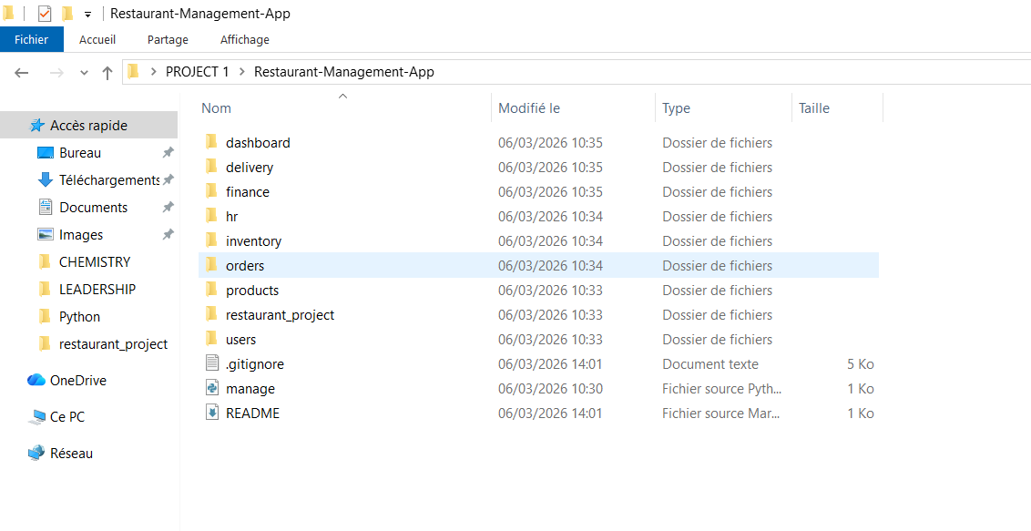
Step 4: Configuring MySQL in settings.py
We then configured the connection between Django and the MySQL database. To do this, the DATABASES block in the settings.py file was updated to point to the Restaurant database, using the standard port 3306 and the utf8mb4 encoding that matches the existing database.
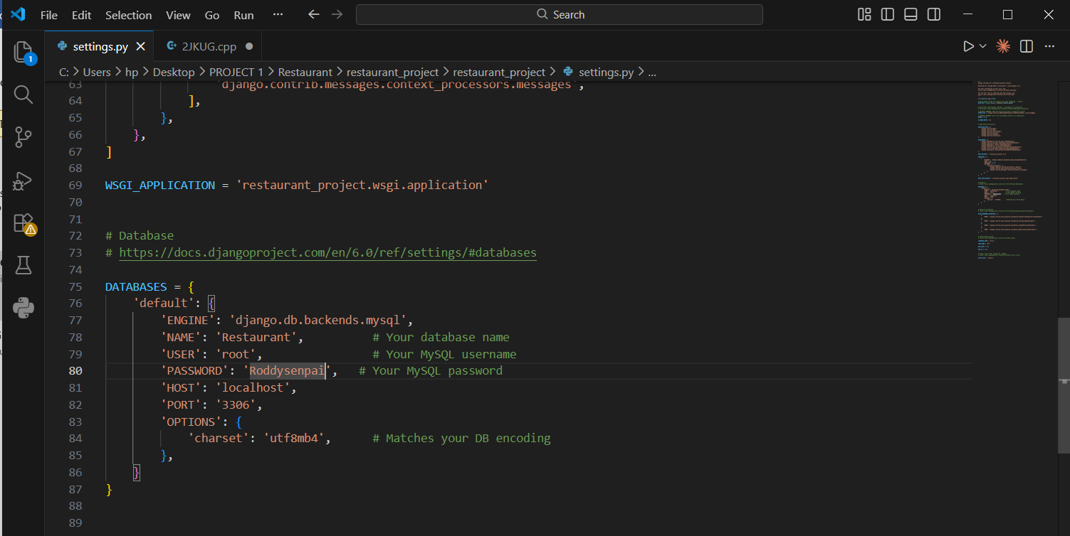
Step 5: Registering the Apps in settings.py
For Django to recognise the eight applications created in Step 3, each one was added to the INSTALLED_APPS list in settings.py. Without this step, Django would completely ignore those modules.
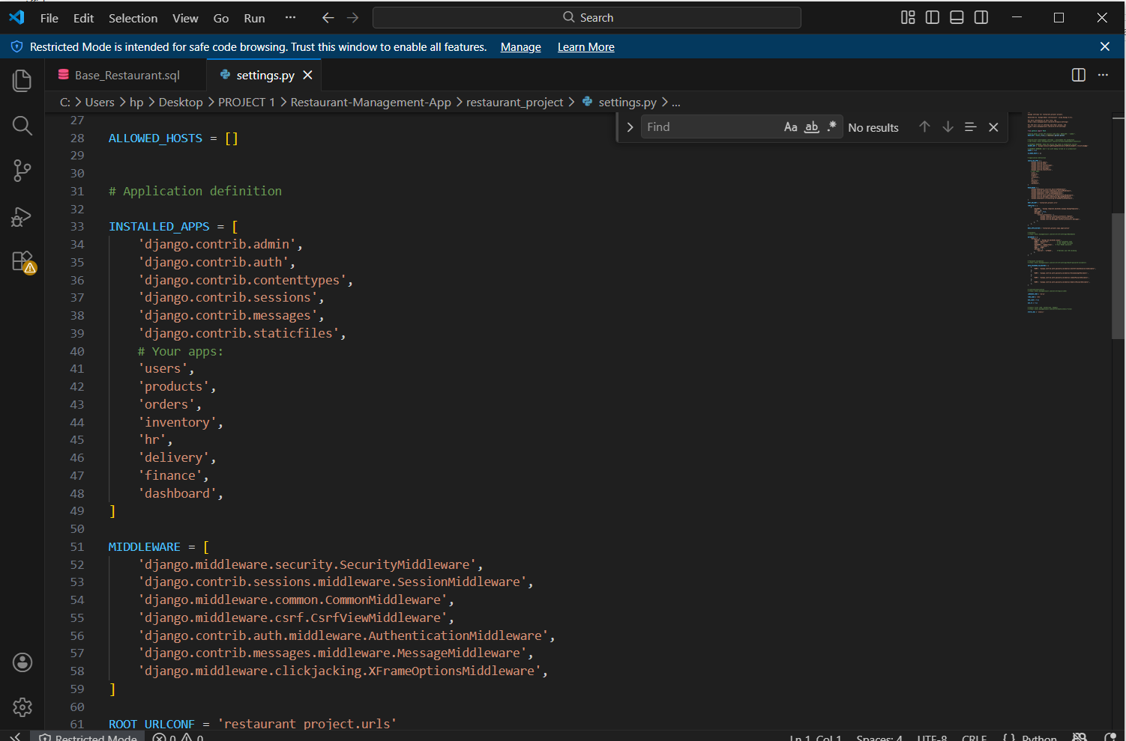

Step 6: Importing the MySQL Database
The database file provided for the project (Base_Restaurant__1_.sql) already contains all 23 tables as well as test data. This database was imported directly into MySQL via the Windows Command Prompt.

6.1 Installing MySQL
Before importing, it was necessary to install MySQL Server on our Windows machine. We downloaded the installer from the official website dev.mysql.com/downloads/installer, selected the Custom installation type to limit data usage, and configured the server with a root password.
After installation, the path to the MySQL executables was added to the Windows system environment variables (PATH) so that the mysql command could be used from any terminal:

C:\Program Files\MySQL\MySQL Server 8.0\bin
6.2 Importing the SQL File
Once MySQL was correctly installed and accessible from the terminal, we navigated to the folder containing the SQL file and ran the import command:

cd "C:\Users\hp\Desktop\PKFOKAM\FRESHMAN 1\Python"
mysql -u root -p < Base_Restaurant__1_.sql
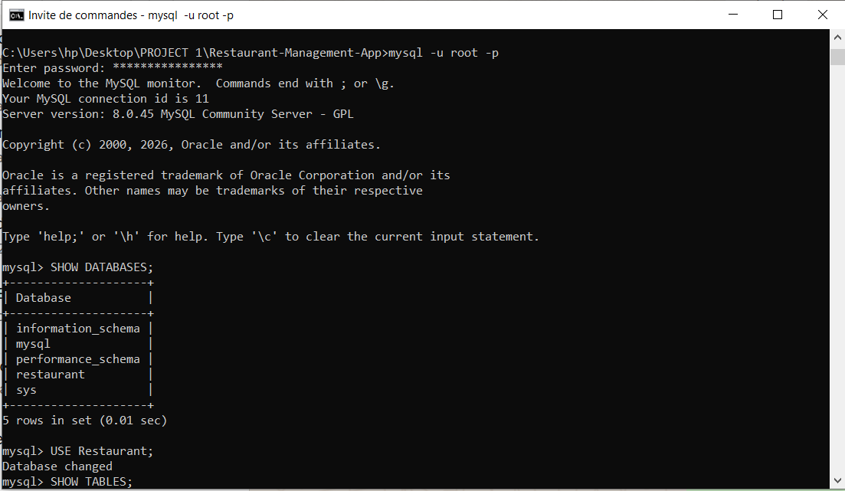
When prompted, we entered the MySQL root password. The absence of any error message confirmed that the import was successful.
6.3 Verifying the Import
After importing, we verified that the database and its 23 tables were correctly present in MySQL by running the following commands:

mysql -u root -p
SHOW DATABASES;
USE Restaurant;
SHOW TABLES;
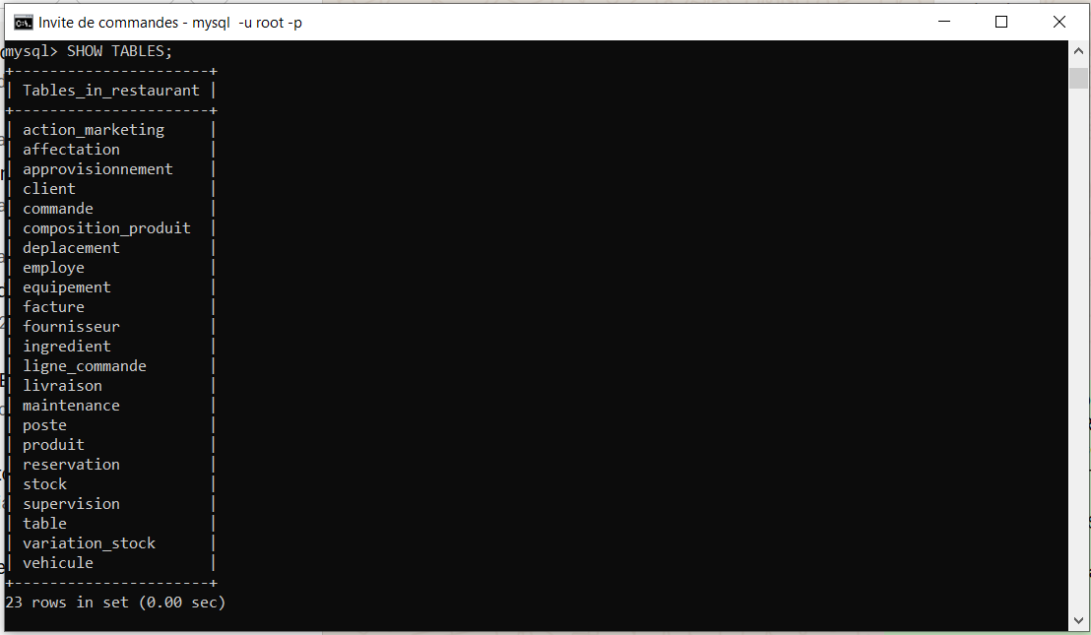
Step 7: Testing the Django–MySQL Connection
The final step of Phase 1 was to verify that Django communicates correctly with the MySQL database. This check is performed with the following command, run from the root folder of the project:

python manage.py check

# Expected result:
# System check identified no issues (0 silenced).

A result with zero errors confirms that the Phase 1 configuration is complete and that the project is ready for Phase 2, which involves writing the Django models for all 23 database tables.
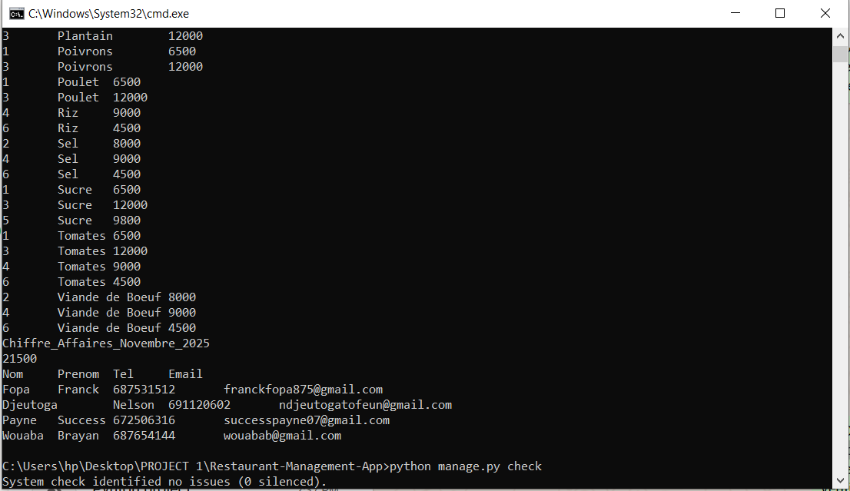

3. Setting Up the GitHub Repository
Alongside the Django project configuration, our group set up the GitHub repository for the project, in compliance with the project requirement that mandates the use of GitHub for source code management and collaborative development.
3.1 Creating GitHub Accounts
Each member of the group created a personal account on github.com. Usernames were chosen to be professional and easily identifiable by the lecturer, as the repository is set to Public.
3.2 Creating the Repository
The group leader created the public repository with the following settings:
Here is the github link to access our repository : https://github.com/pettangroddysenpai-ship-it/Restaurant-Management-App

Setting | Value Chosen
Repository Name | Restaurant-Management-App
Visibility | Public
README File | Added automatically
.gitignore | Python template selected
Repository Link | https://github.com/pettangroddysenpai-ship-it/Restaurant-Management-App

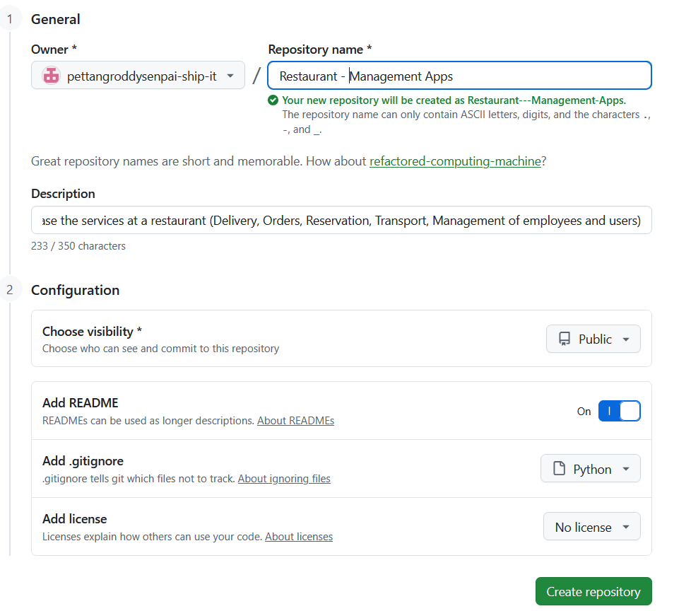
3.3 Adding Collaborators
The remaining group members were added as collaborators through the Settings → Collaborators page of the repository. Each member received an email invitation from GitHub which they accepted in order to gain push access to the repository.

# Navigate directly to the collaborators page:
https://github.com/pettangroddysenpai-ship-it/Restaurant-Management-App/settings/access

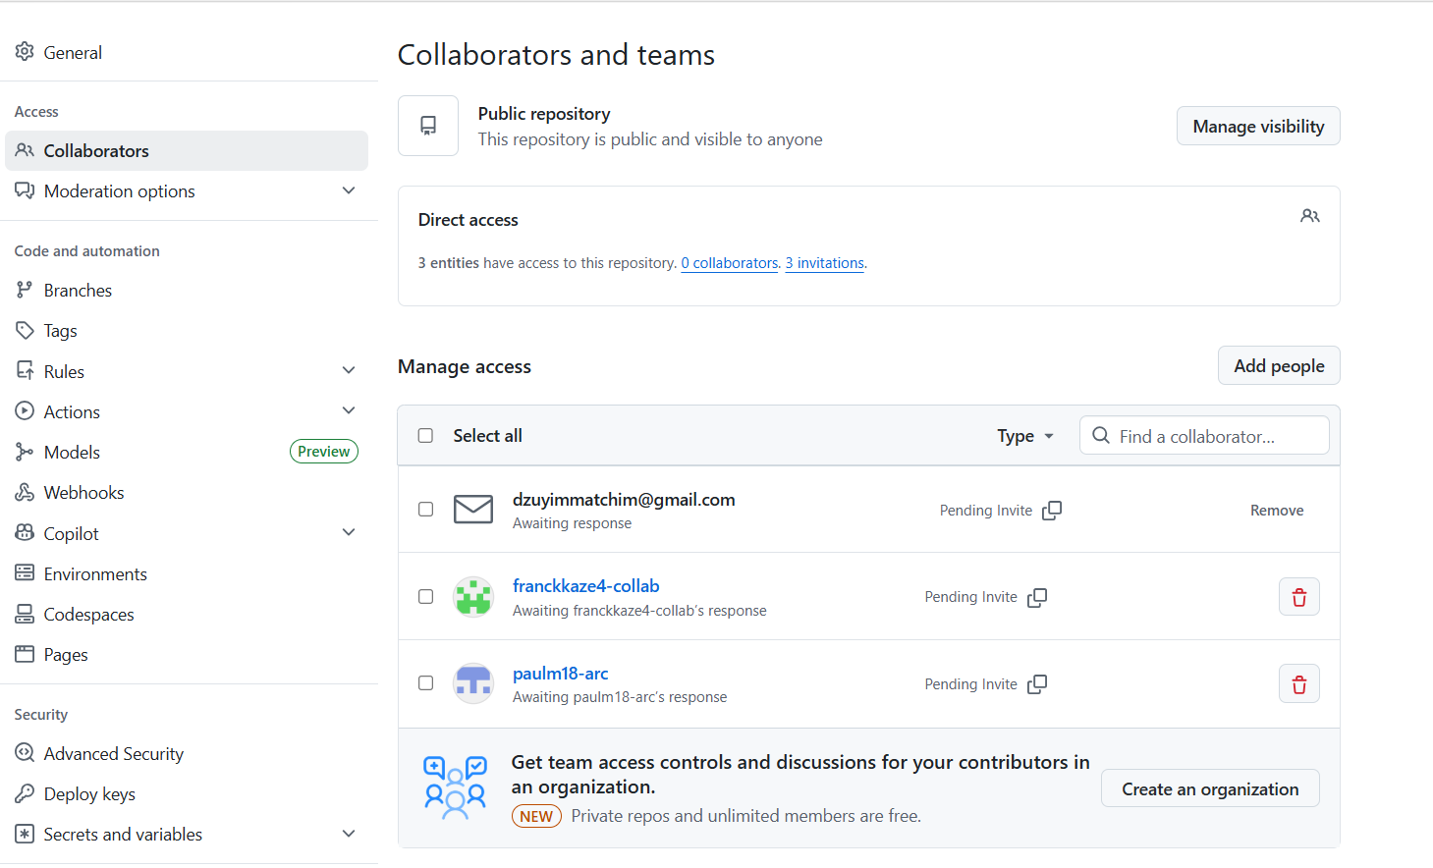
3.4 Cloning the Repository and First Push
After accepting their invitations, each group member cloned the repository onto their local machine. The group leader then performed the first push of the Django project structure to GitHub:

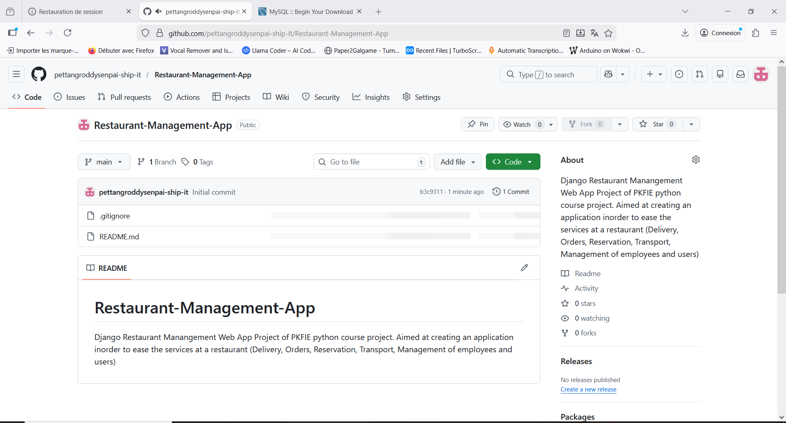
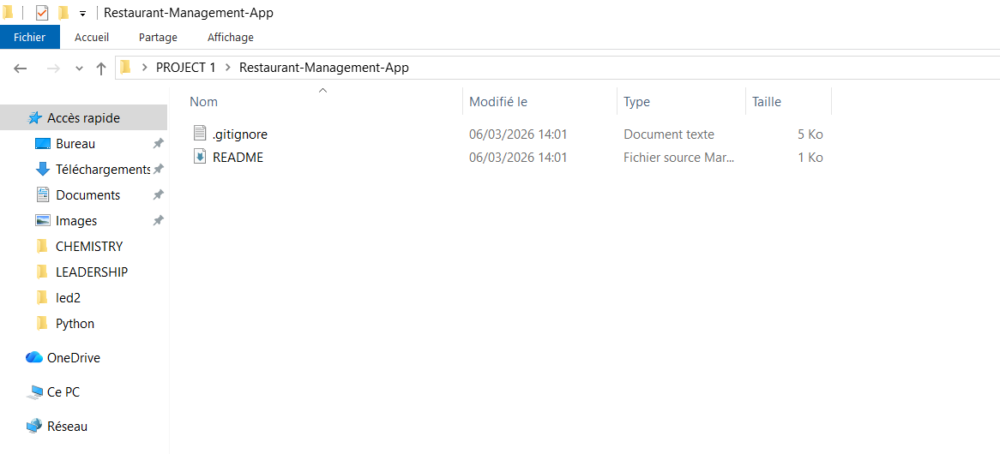
4. Phase 1 Summary
All steps of Phase 1 were completed successfully. The table below provides a full summary of the progress made during this phase:

# | Step | Status | Done By
1 | Install required Python packages (Django, mysqlclient, pillow, python-decouple) | ✅ Complete | Group
2 | Create the Django project with django-admin startproject | ✅ Complete | Group
3 | Create the 8 Django application modules | ✅ Complete | Group
4 | Configure MySQL connection in settings.py | ✅ Complete | Group
5 | Register all 8 apps in INSTALLED_APPS | ✅ Complete | Group
6 | Install MySQL, add to PATH, and import Base_Restaurant.sql | ✅ Complete | Group
7 | Test the Django–MySQL connection with manage.py check | ✅ Complete | Group
8 | Create GitHub repository and add all collaborators | ✅ Complete | Group

With Phase 1 fully complete, our group is now ready to begin Phase 2, which will involve writing the Django models for all 23 database tables and implementing the authentication system with role-based access control for the six user types defined in the project specifications.

